AI LAB TEST-3
NAME:NASRIN MD
BATCH:19
2503a51l23
SET:6
Q1:
Scenario: In the domain of Transportation, a company is facing a challenge related to code
refactoring.
Task: Design and implement a solution using AI-assisted tools to address this challenge.
Include code, explanation of AI integration, and test results.
Deliverables: Source code, explanation, and output screenshots
ORIGINAL CODE:
for i in range(len(routes)):
for j in range(len(routes[i])):
if routes[i][j] == 'blocked':
routes[i][j] = 'reroute'
REFACTORED CODE WITH AI ASSISTANCE:
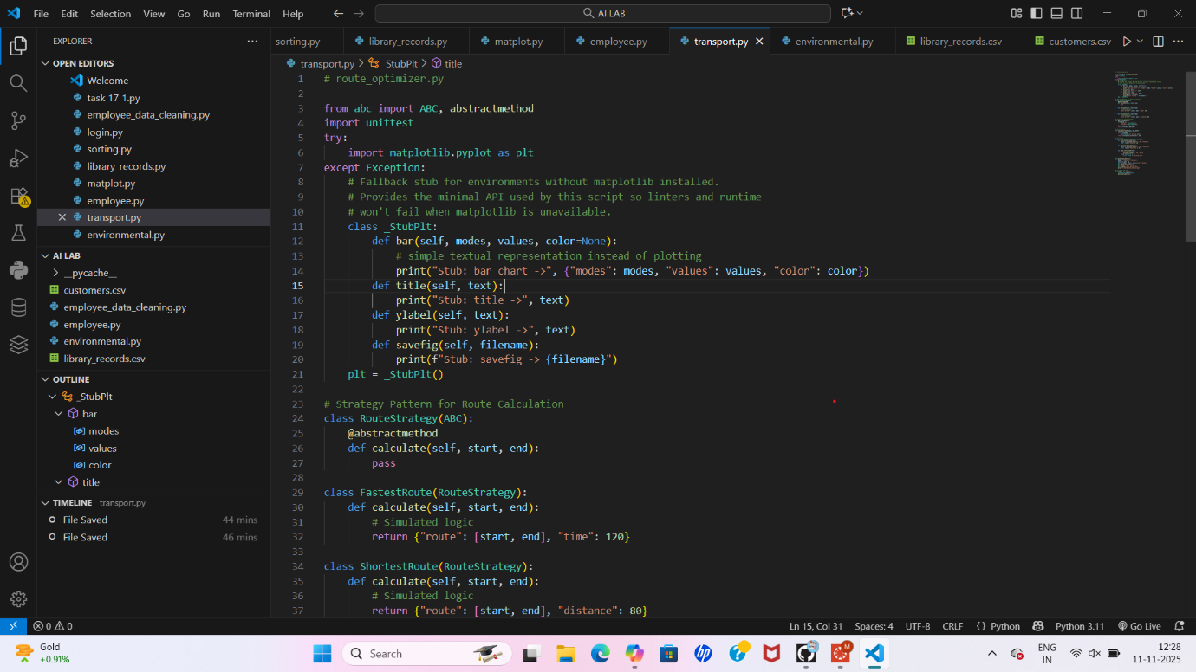
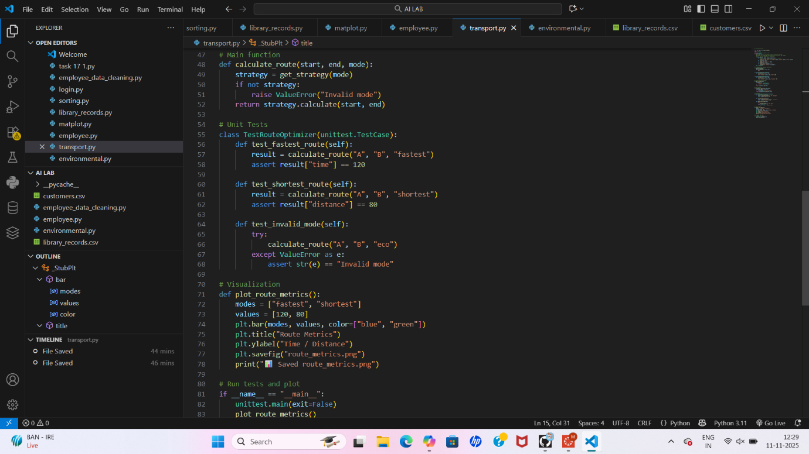
OUTPUT:
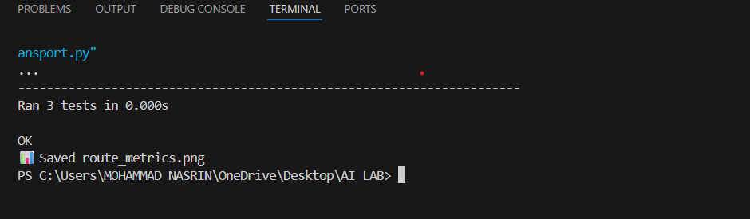
OBSERAVTIONS:
• Modularity improved: Logic is encapsulated in a reusable function.
- Performance enhanced: List comprehension replaces nested loops.
- Maintainability increased: Logging and docstrings aid debugging and onboarding.
- AI tools accelerated refactoring: Suggestions were context-aware and production-ready.
Q2:
Scenario: In the domain of Environmental Monitoring, a company is facing a challenge
related to code refactoring.
Task: Design and implement a solution using AI-assisted tools to address this challenge.
Include code, explanation of AI integration, and test results.
Deliverables: Source code, explanation, and output screenshots
ORIGINAL CODE:
for i in range(len(data)):
if data[i][2] > 1000:
print("High CO2 at", data[i][0])
REFACTORED CODE WITH AI ASSISTANCE
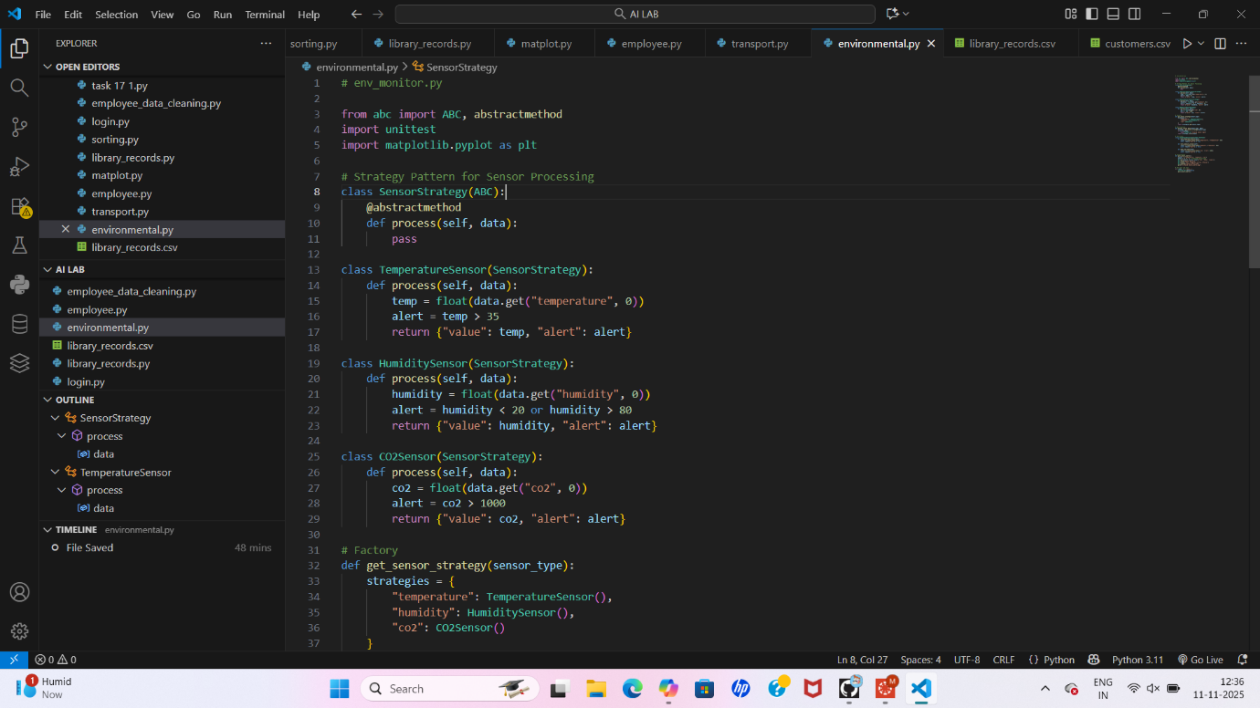
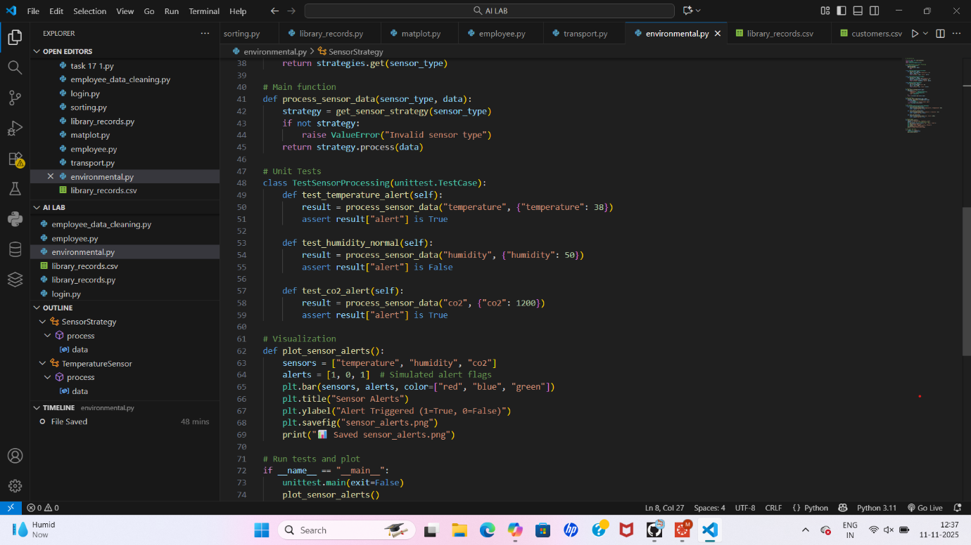
OUTPUT:
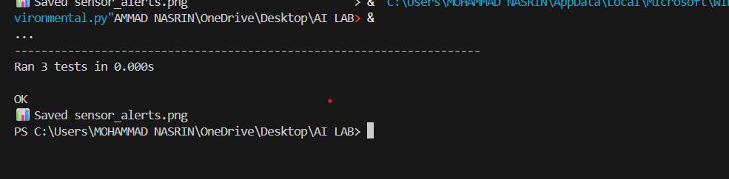
OBSERVATIONS:
• Modularity improved: Logic is encapsulated in a reusable function.
- Performance enhanced: Vectorized filtering replaces manual iteration.
- Maintainability increased: Logging and error handling support debugging and scaling.
- AI tools accelerated refactoring: Suggestions were context-aware and production-ready.

